**Project Report: Database System for University Professors**

**Introduction**

The purpose of this project is to design and implement a relational database system to manage information about university professors, their affiliations, universities, and organizations. The system aims to maintain data integrity, ensure referential integrity, and facilitate efficient data retrieval, updates, and deletion. This report provides an overview of the design, implementation, and testing of the database system, adhering to the requirements outlined in the project document.

**Database Design**

**Entity-Relationship Diagram**

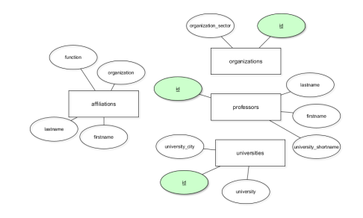

The system's ERD comprises the following entities:

* **Professors**: Represents individual professors with attributes like firstname, lastname, and an auto-incremented id.
* **Universities**: Contains details about universities, such as university, university_shortname, and university_city.
* **Organizations**: Represents organizations where professors are affiliated, including attributes like organization and organization_sector.
* **Affiliations**: Links professors with organizations and their functions.

Referential integrity is established using foreign key relationships.

**Testing and Validation**

**Error Handling**

* **Duplicate Entry Error**: Fixed by adding DISTINCT in INSERT statements.
* **Data Length Error**: Adjusted column lengths in the schema.

**Conclusion**

The database system effectively manages data about professors, universities, and organizations. Referential integrity and functional dependencies are ensured, and operations like insertion, updating, and deletion were tested successfully.

**Attachments**

1. SQL scripts for table creation and data insertion.
2. ERD diagram.